
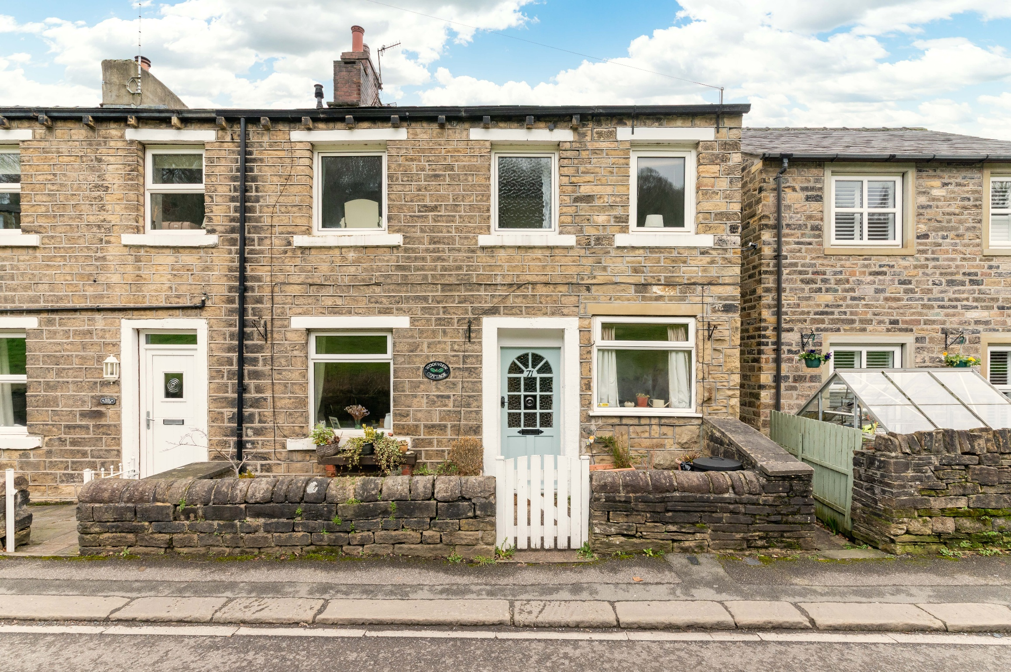
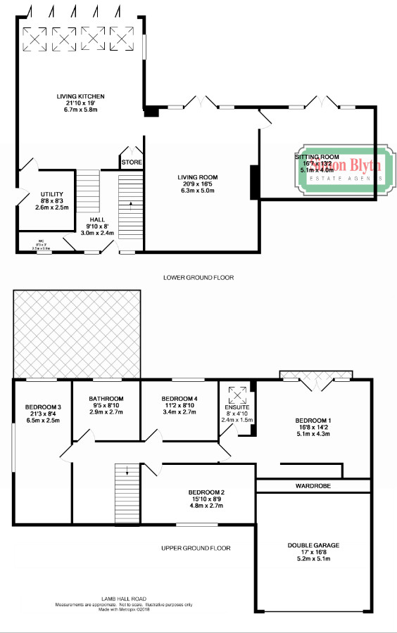
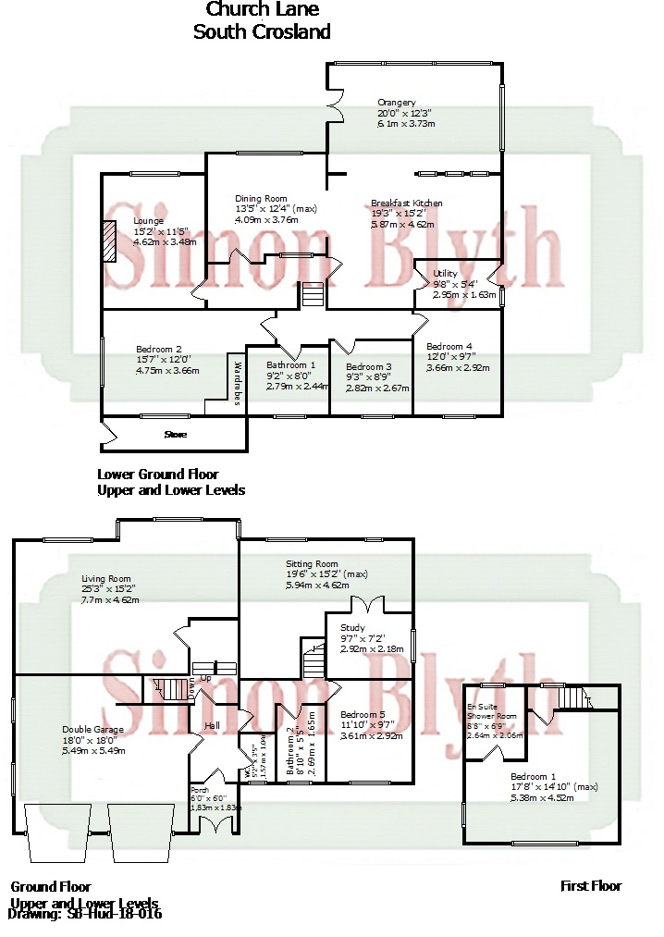
ARMITAGE ROAD, ARMITAGE BRIDGE, HD4 7PD
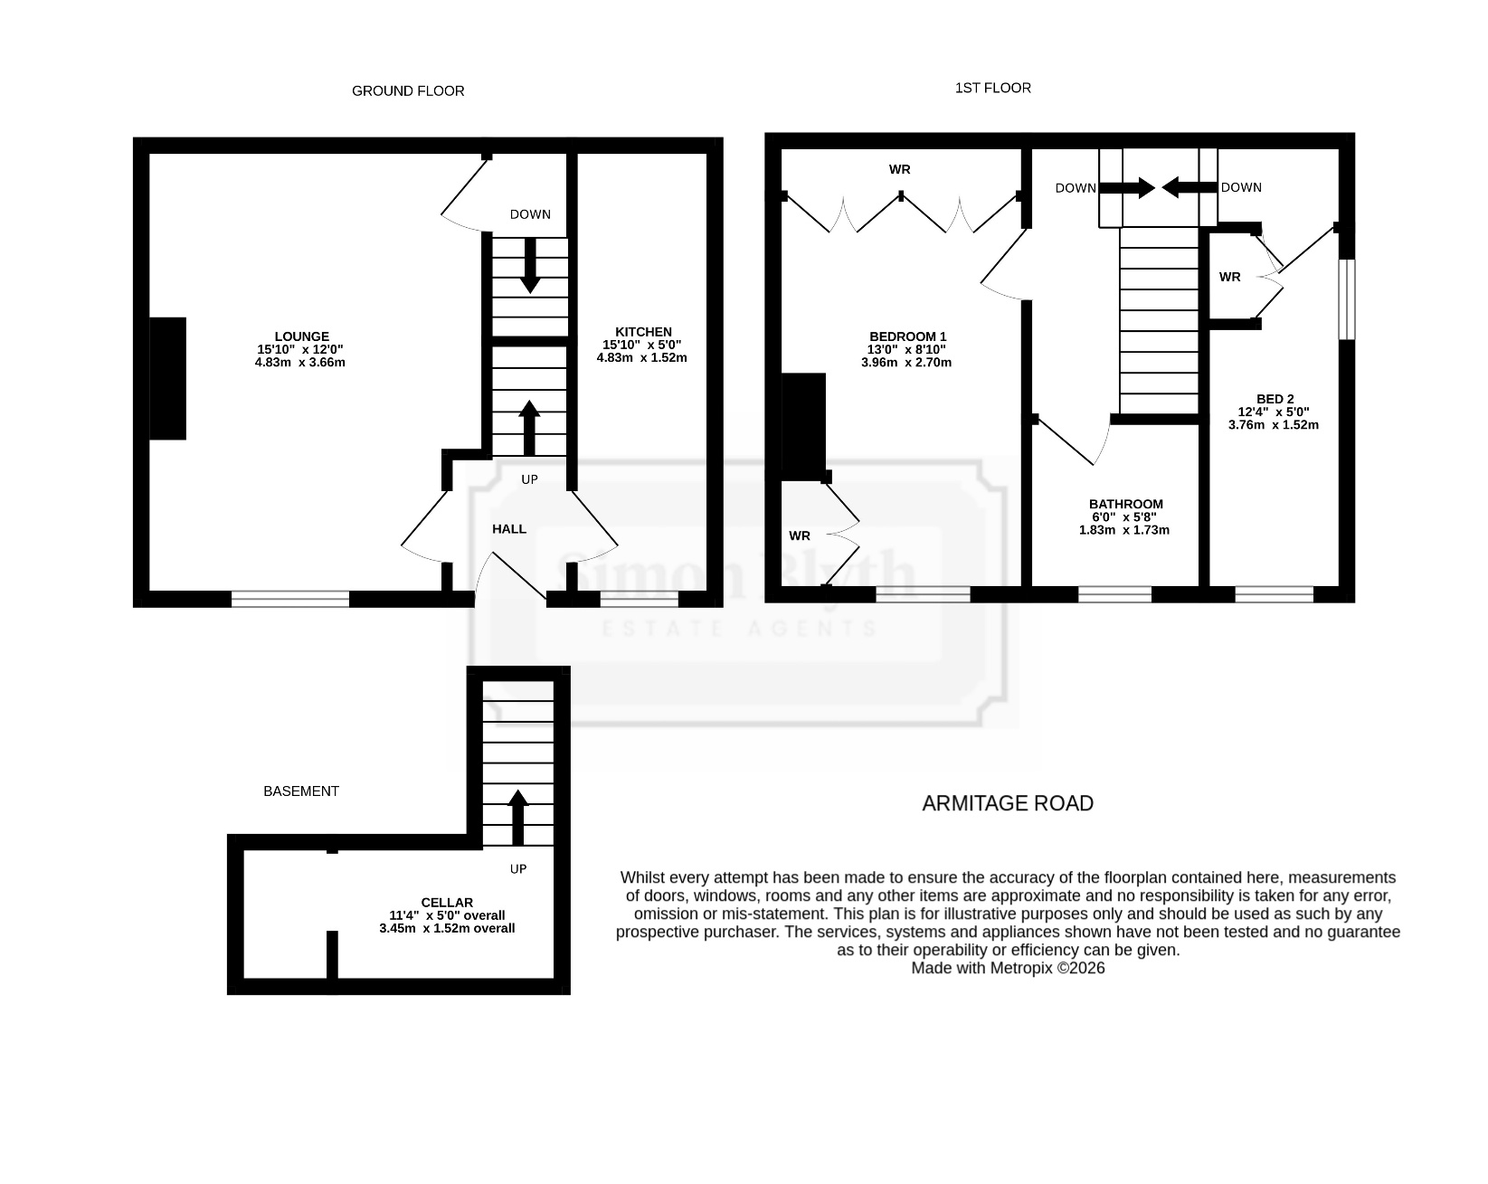

PROPERTY DESCRIPTION

A DOUBLE FRONTED, BACK-TO-BACK, END TERRACE COTTAGE, TUCKED AWAY IN THE QUIET, BACK-WATER AREA OF ARMITAGE BRIDGE. OFFERING DELIGHTFUL VIEWS, AND WITH NO ONWARD CHAIN, THE PROPERTY IS CONVENIENTLY POSITIONED FOR ACCESS TO COMMUTER LINKS, A CLOSE TO THE NEIGHBOURING VILLAGES OF HONLEY AND NETHERTON.
The property accommodation briefly comprises of entrance, open-plan living/dining room and kitchen to the ground floor. To the lower ground floor is a useful cellar with lighting and power, to the first floor there are two bedrooms and the house bathroom. Externally there is a courtyard style, enclosed garden to the front ideal for sitting out and enjoying the field and woodland outlook.

EPC rating: C Council tax: A Tenure: Freehold

Offers Around £150,000

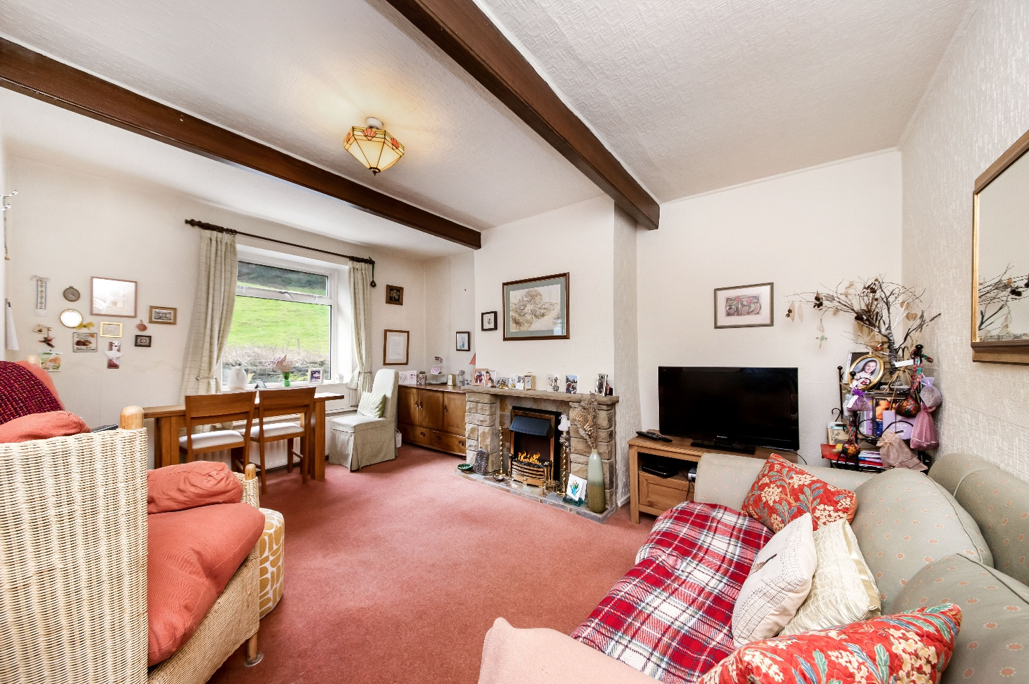
OPEN PLAN LIVING DINING ROOM
Measurements – 15’10” x 12’0”
The open plan living dining room is a generous proportioned reception room which features a double-glazed window to the front elevation with pleasant open aspect view across a neighbouring field and with a tree lined backdrop. There are exposed timber beams to the ceiling, two radiators, a central ceiling light point, and the focal point of the room is the electric fireplace with a natural slate inset and hearth and with decorative stone surround. A door then encloses the staircase which descends to the lower ground floor.

ENTRANCE
Enter the property through a multi-panel timber and glazed front door with obscure glazed inserts into the entrance. The entrance has a staircase with two handrails proceeding to the first floor, a radiator and ceiling light point. A multi-panel timber and glazed door with obscure glazed inserts leads into the open plan living dining room. and a concertina panelled door leads into the kitchen.

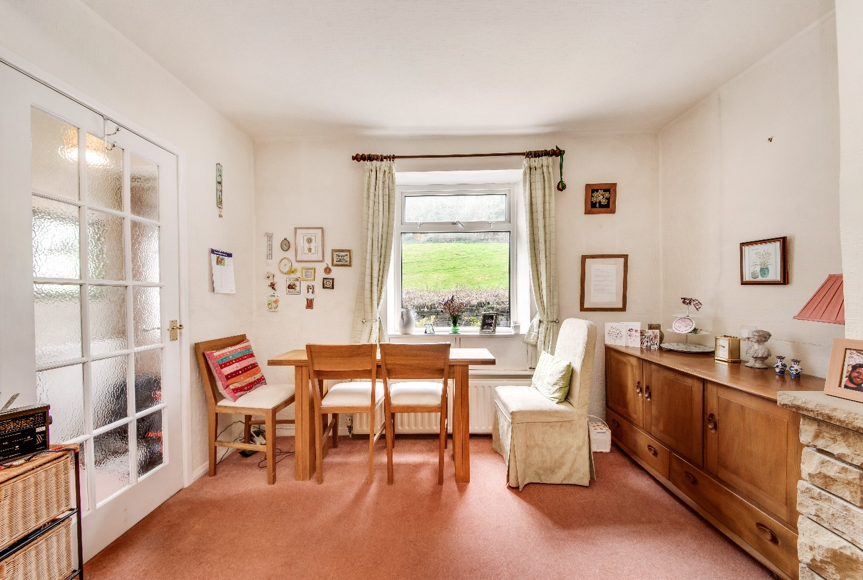

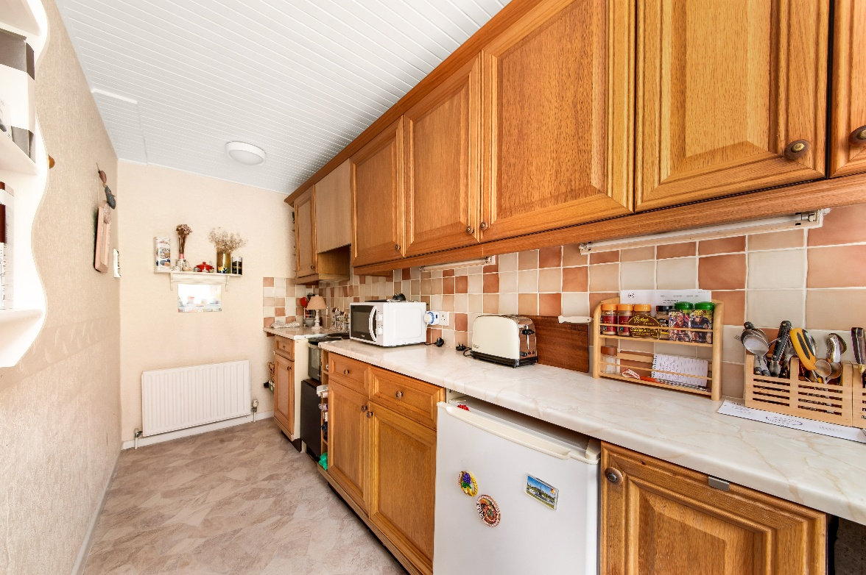
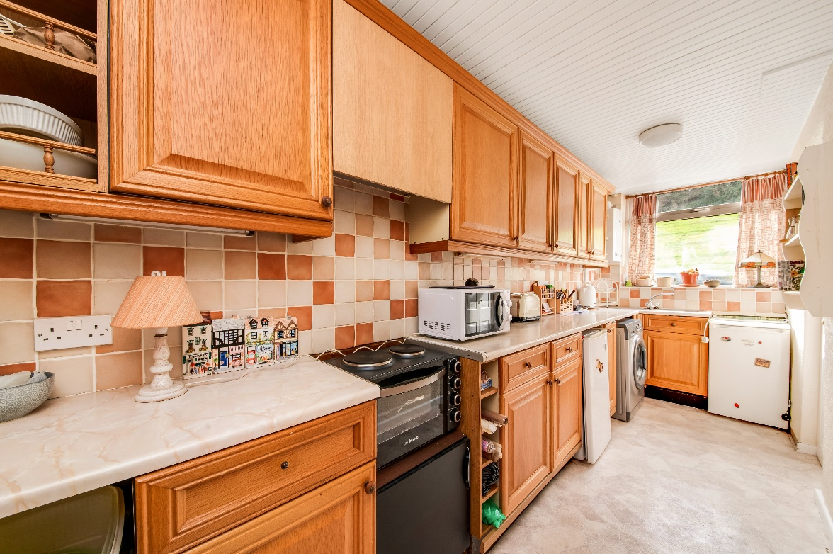
KITCHEN
Measurements – 15’10” x 5’0”
The kitchen features a range of fitted wall and base units with shaker style cupboard fronts and with complimentary rolled edge work surfaces over which incorporate a single bowl stainless steel sink and drainer unit with mixer tap. There is tiling to the splash areas, under unit lighting, space and provisions for an automatic washing machine and under counter fridge and freezer units and there is space for an electric cooker with integrated cooker hood over. Additionally, there is a panelled ceiling with two ceiling light points, a radiator and a double-glazed window to the front elevation with pleasant open aspect views. The kitchen also houses the wall-mounted Worcester Bosch boiler.

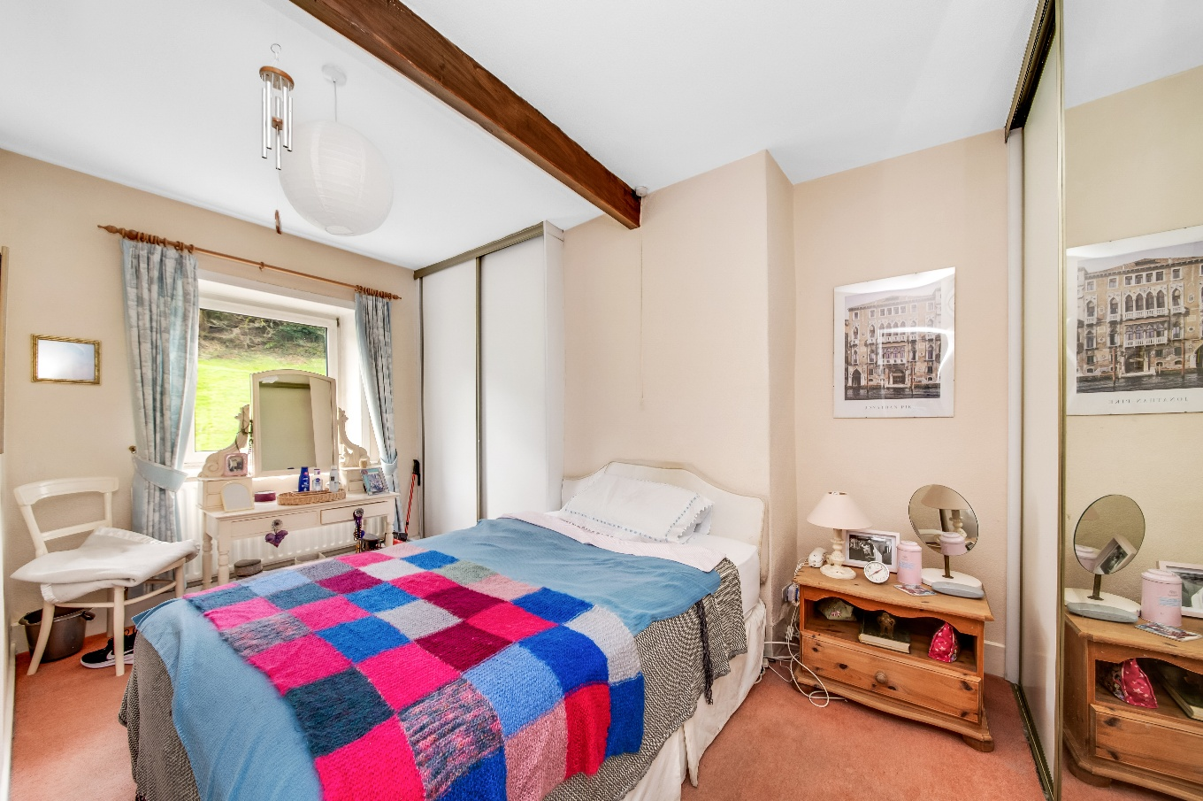
BEDROOM ONE
Measurements – 13’0” x 8’10”
Bedroom one can accommodate a double bed and features two sets of fitted wardrobes which have sliding doors and with hanging rails and shelving in situ. There is an exposed timber beam to the ceiling, a ceiling light point, radiator and a double-glazed window to the front elevation which has pleasant views across a field and of a tree-lined backdrop.

LOWER GROUND FLOOR
Measurements – 11’4” x 5’0” overall
Taking the stone stairwell from the lounge, you reach the lower ground floor cellar, which has lighting and power in situ and is separated into two rooms. The first of which features the original stone keeping slab and with two recessed stone shelves for storage.

FIRST FLOOR LANDING
Taking the carpeted stone staircase from the entrance, you reach the first-floor landing, which has doors providing access to two bedrooms and the bathroom. There are two ceiling light points, an exposed timber beam to the ceiling, a loft hatch which gives access to a useful attic space and there is a single glazed window above the bathroom door that provides borrowed light into the landing.

BEDROOM TWO
Measurements – 12’4” x 5’0”
Bedroom two is a dual aspect single bedroom which features a floor to ceiling, fitted wardrobe, which has a hanging rail and with storage cupboard above. There is exposed timber floorboarding, a ceiling light point, radiator and double-glazed windows to both the front and side elevations.

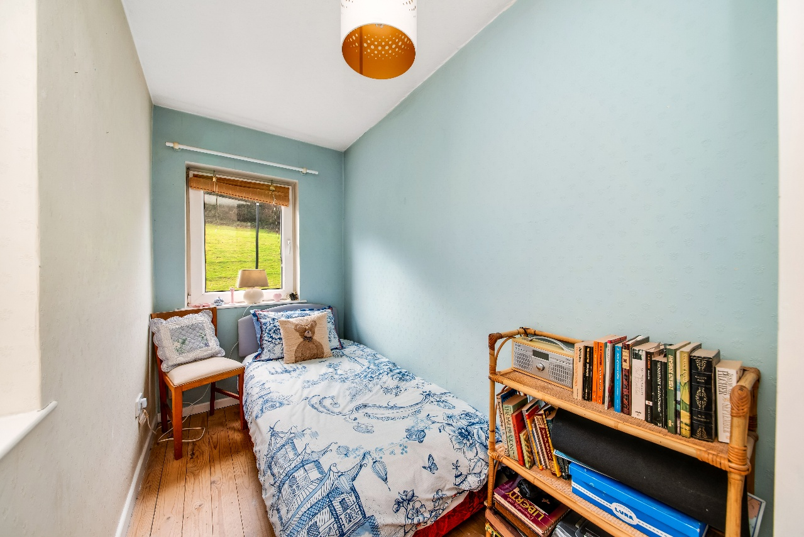
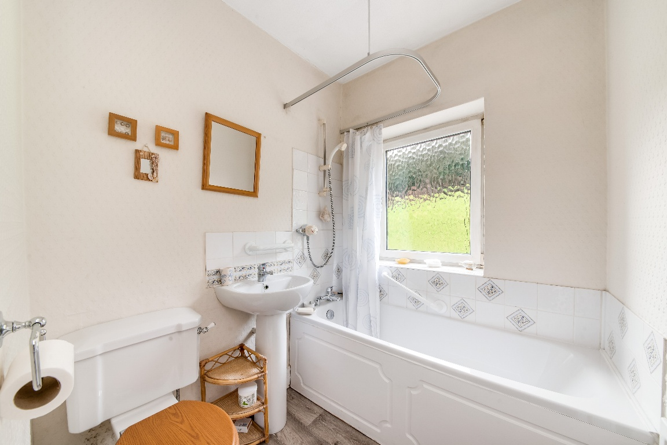
BATHROOM
Measurements – 6’0” x 5’8”
The bathroom features a white three-piece suite, which comprises panel bath with Myra XL shower over, a pedestal wash hand basin with chrome monobloc mixer tap and a low level w.c. There is tiling to the splash areas, a double-glazed window with obscure glass and tiled sill to the front elevation, a ceiling light point and radiator.

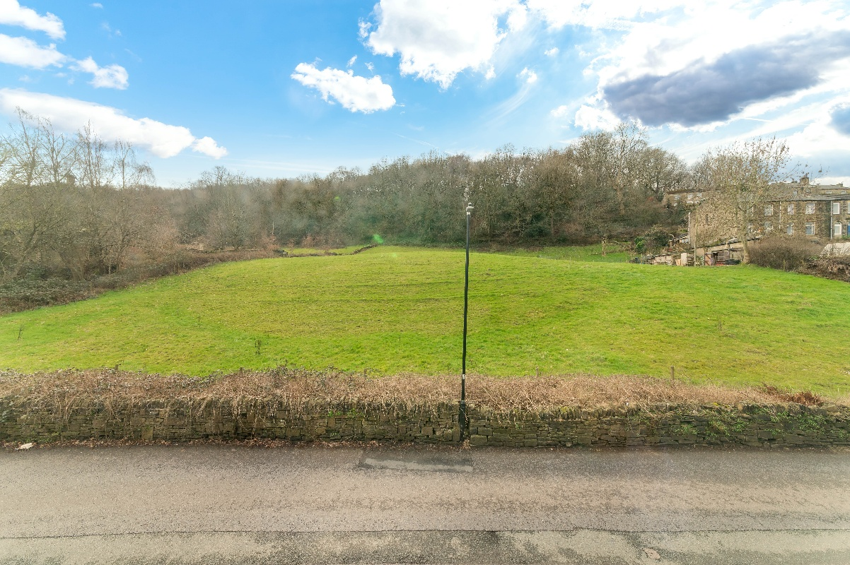
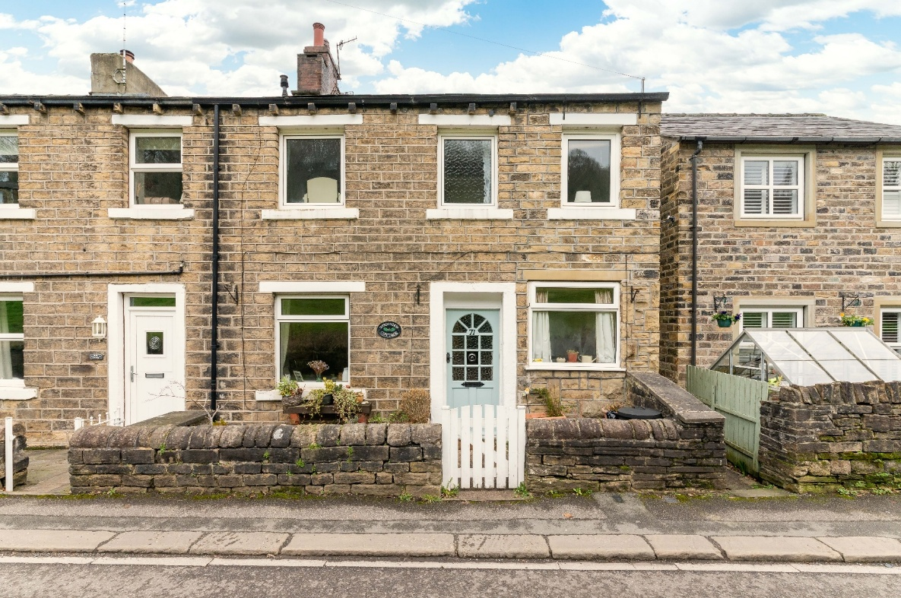
EXTERNAL FRONT
Externally to the front, the property features a low maintenance and enclosed courtyard style garden with stone wall boundaries and is a pleasant space to sit out and enjoy the views across a field and of the tree-lined outlook.

Please note that the property is a front-facing back-to-back cottage so there is no rear external.

ADDTIONAL INFORMATION
EPC rating – C
Property tenure – Freehold
Local authority – Kirklees Council
Council tax band – A

BOUNDARY OWNERSHIP
The boundary ownerships and tenure of the property have not been checked on the title deeds for any discrepancies or rights of way if any (This is a standard statement on all our brochures due to the Property Misdescription's Act)

COPYRIGHT
Unauthorised reproduction prohibited.

FREE VALUATIONS
If you are thinking of a move then take advantage of our FREE valuation service, telephone our nearest office for a prompt and efficient service.

CONSUMER PROTECTION FROM UNFAIR TRADING REGULATIONS 2008
Simon Blyth for themselves and for the vendors or lessors of this property, whose agent they are, have made every effort to ensure the details given have been prepared in accordance with the above act and to the best of our knowledge give a fair and reasonable representation of the property. Please note:

1. There is a six inch measurement tolerance or metric equivalent and the measurements given should not be entirely relied upon and purchasers must make their own measurements
if ordering carpets, curtains or other equipment.

2. None of the main services, i.e. gas, water, electricity, drainage or central heating system (if any)
have been tested in any way whatsoever. This also includes appliances which are to be left in situ by the vendors.

PURCHASERS MUST SATISFY THEMSELVES AS TO THE CONDITION AND EFFECTIVENESS OF ANY
SUCH APPLIANCES OR SERVICES

FLOOR PLANS NOT TO SCALE - FOR IDENTIFICATION PURPOSES ONLY

MAILING LIST
Keep up to date with all our new properties. Let us know your price range, the area and type of home you require by registering on our mailing list.

MORTGAGE ADVICE
Simon Blyth Estate Agents understand that getting appropriate mortgage advice is a crucial part of the home buying process. Finding a suitable mortgage has always been something of a daunting experience which is why we would like to introduce you to our independent mortgage advisors. They provide tailored mortgage solutions through a wealth of experience in the mortgage and property market and offer access to the full unrestricted range of products available.

Our advisors are dedicated to providing ongoing guidance and advice throughout the entire house purchase process keeping you, your estate agent and solicitor involved with continual updates on the progress. Once in your new home they will be available for ongoing support to build a long-term relationship for your future mortgage planning. Your home may be repossessed if you do not keep up repayments on your mortgage.

For friendly expert advice on your mortgage requirements, or to discuss the potential of making your ideas a reality then please call in or phone for a chat.

OFFICE OPENING TIME
7 DAYS A WEEK
Monday to Friday - 8.45 to 17:30
Saturday - 9:00 to 16:30
Sunday - 11:00 to 16:00

Wakefield  01924 361631 | Huddersfield  01484 651878 | Holmfirth  01484 689689 | Kirkburton  01484 603399 | Penistone  01226 762400 | Sheffield  01143 216 590 | Barnsley  01226 731730 | Pontefract  01977 800259

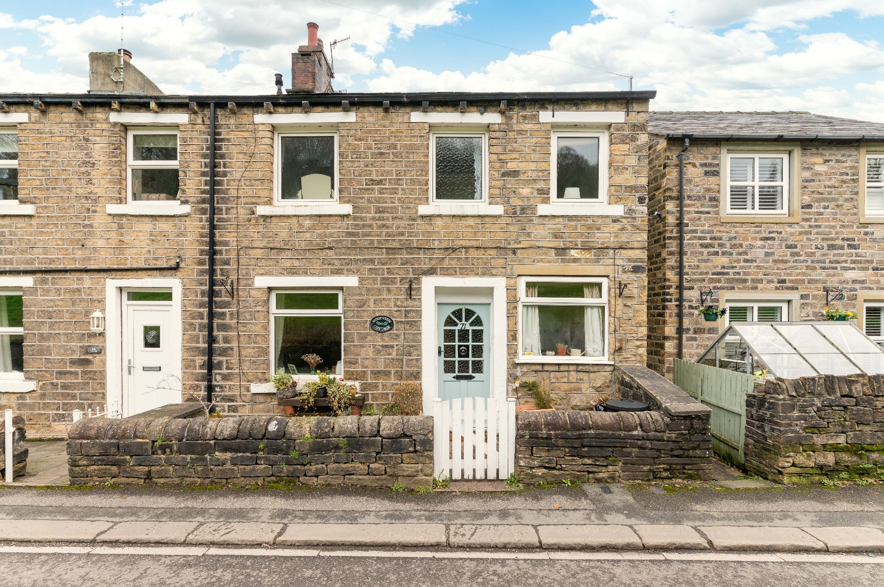

MAIN CONTACTS
T: 01484 689689
W: www.simonblyth.co.uk
E: holmfirth@simonblyth.co.uk

OFFICE OPENING TIMES
7 DAYS A WEEK
Monday to Friday - 8.45 to 17:30
Saturday - 9:00 to 16:30
Sunday - 11:00 to 16:00
WWW.SIMONBLYTH.CO.UK

